**Vehicle Rental Management System**

**Project report:**

This system is based on a concept to rent cars and generate rental invoice of a rental company. Before stepping into the main system a user has to pass through a login system to get access, then only the user can select cars with a different model and rent for certain days. This mini project contains limited features, but the essential one.

Talking about the features of this Rental System, after logging in as a user he/she has to provide a name then the user can select available cars. After selecting a car, the system displays selected car details which contain maximum power, mileage and many more. Then the user has to provide information such as number of days to rent the car. After all these procedures, the system calculates rent and displays Customer Invoice presenting invoice number, customer’s name, car model, number, number of days and total rental amount.

**Modules included in this project: -**

**Passenger Information Module** - We can create update and delete Passenger Information from this module

**Cars Module** - All the operations related to Cars, is managed by this module

**Car Booking Module** - Car Booking Module is used to manage the Car Booking System

**Car Routes Module** - It has been developed for managing the routes of the Car

**Drivers Module** - It manages the Drivers

ER Diagram

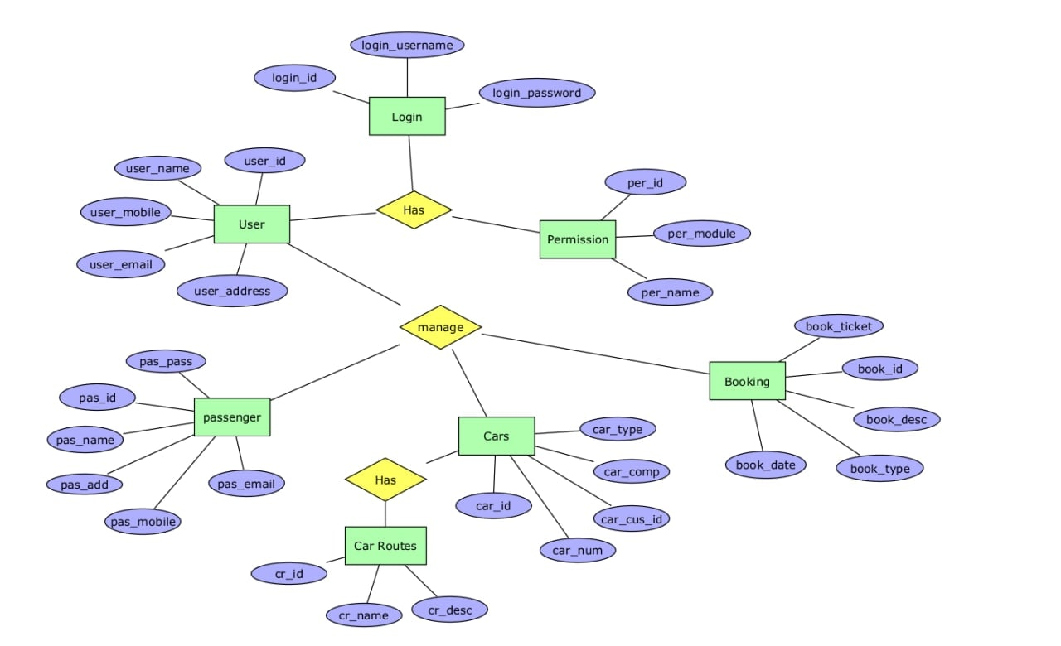

Class Diagram

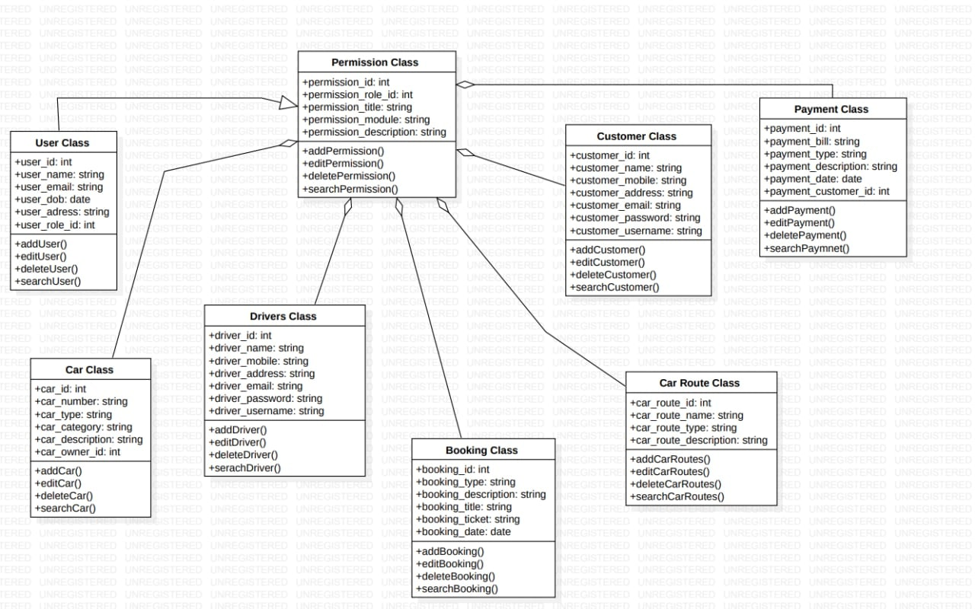

Sequence diagram

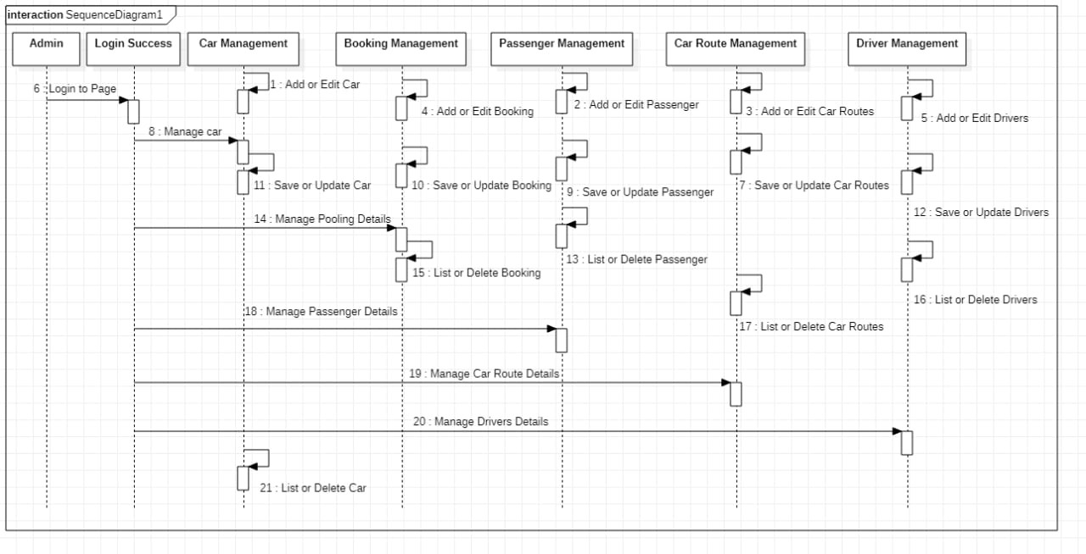

Usecase diagram

